**Orange HRM Automation:**

The website I have chosen to test is Orange HRM (<https://opensource-demo.orangehrmlive.com/>) .It’s basically an HR – management system that manages HR System for small, medium, large size business. It is an open source platform.

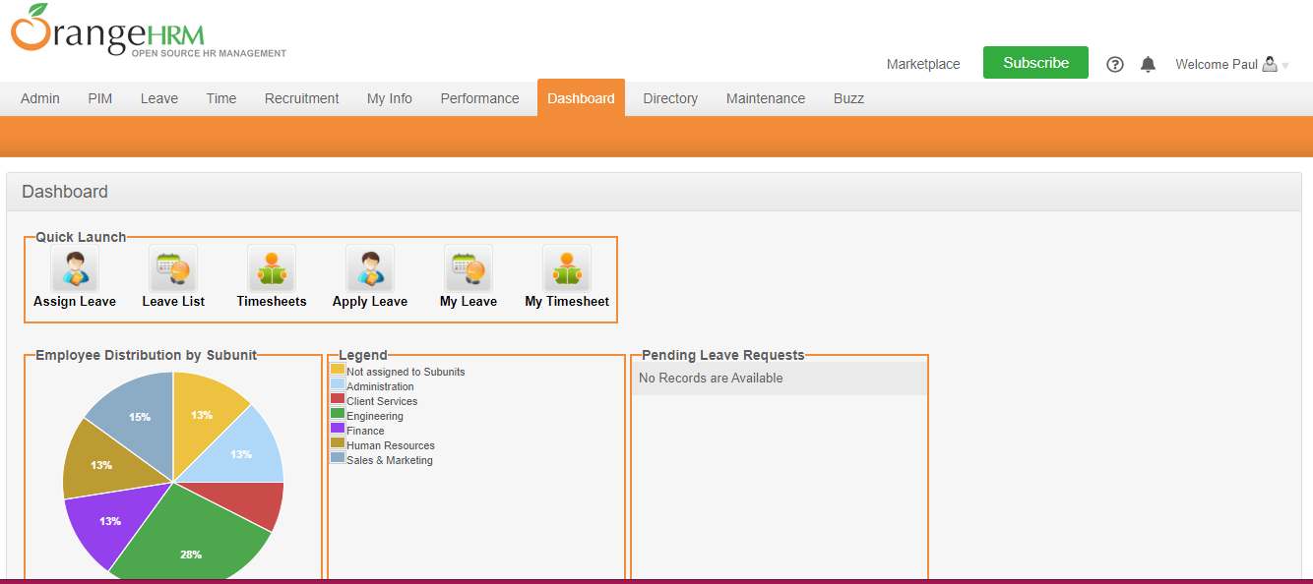

**Use Selenium Framework:**

Selenium could run test ware directly on the target browser, drive the interaction on the required website and return them without any manual input.

I have written a total of ‘36’ test cases by using Selenium in C-Sharp language using Microsoft Visual Studio 2019

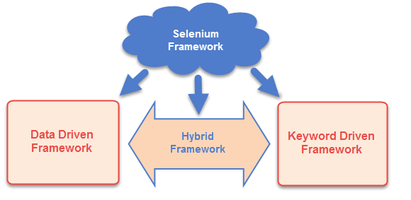

**Page Object model Approach**

Basically it is object Design pattern in selenium which creates an object repository to store all web elements, which reduce Duplication in code and increase maintenance.

We suppose each web page as individual class file, each class consist of corresponding web page element.

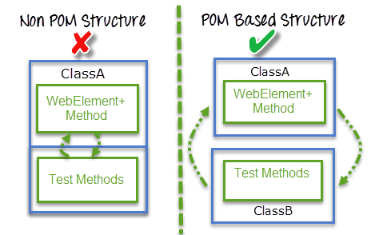

**Tested Features:**

To test the following features (including positive and negative test scenarios and validation):

* Login
* Logout
* Add user
* Delete user
* Search user
* Reset search record
* Subscribe
* About option
* Support option
* Add employee
* Search employee
* Add Job title
* Add Pay grade
* Search record in directory
* Update Buzz status
* Update Buzz Image
* Verify password then add employee
* Add pay Grades and further add currency
* Market place

**Element locators that are used:**

* Xpath
* Name
* Class Name
* Tag Name
* Id

**Internet Browser used:**

* Google Chrome (updated version)